**Computer Hardwares**

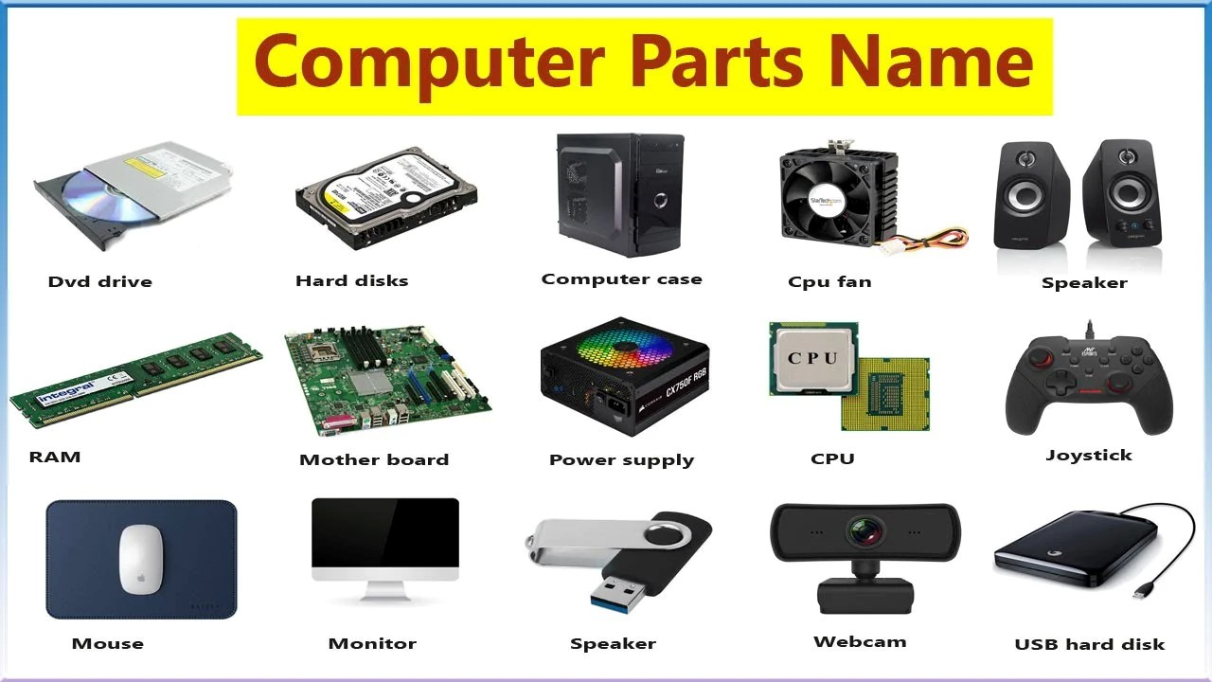

**Computer hardware** refers to the physical components of a computer system that you can touch and see. It includes everything that is physically inside and connected to the computer, such as the **central processing unit (CPU)**, **motherboard**, **memory (RAM)**, **hard drives**, **power supply**, and all the other essential parts that enable the computer to function.

Hardware works in conjunction with software, which provides instructions for the hardware to perform tasks. Without hardware, a computer would not be able to carry out any functions, and without software, the hardware would be inert, as it wouldn't know what tasks to execute.

**Major Components of Computer Hardware:**

**1.CPU (Central Processing Unit)**

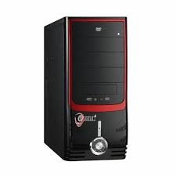

A CPU, or Central Processing Unit, is a computer's main processor that carries out instructions from software programs. It's also known as the "brain" of a computer.

**Structure of the CPU**

The CPU is composed of several important parts that work together to process data. These include:

1. **Arithmetic and Logic Unit (ALU)**The ALU is responsible for performing all arithmetic and logical operations in the CPU. Arithmetic operations include addition, subtraction, multiplication, and division, while logical operations involve comparisons like AND, OR, and NOT. The ALU processes the instructions given to it and generates results that are passed on to other parts of the CPU or memory.
2. **Control Unit (CU)**  
   The Control Unit acts as the director of the CPU, managing the sequence of operations that are to be carried out. It interprets the instructions from the computer's memory, decodes them, and sends out control signals to the other parts of the CPU to execute the required operations. The CU also manages the data flow between the CPU and other components of the system.
3. **Registers**  
   Registers are small, fast storage locations within the CPU. They temporarily hold data, instructions, and memory addresses that are being processed by the CPU. Some important registers include:
   * **Program Counter (PC)**: Holds the memory address of the next instruction to be executed.
   * **Accumulator**: Stores intermediate results from the ALU.
   * **Status Register**: Holds flags that indicate the status of the processor (e.g., overflow, zero, etc.).
4. **Cache Memory**  
   Cache memory is a small but high-speed memory located inside or near the CPU. It stores frequently accessed data or instructions to improve performance by reducing the time it takes to fetch data from the main memory (RAM). There are three levels of cache:
   * **L1 Cache**: The smallest and fastest, located closest to the CPU cores.
   * **L2 Cache**: Larger and slower than L1, often shared between cores.
   * **L3 Cache**: The largest and slowest, but shared by all cores in multi-core processors.
5. **Clock and Clock Speed**  
   The CPU operates based on a clock that generates timing signals at regular intervals. The clock speed (measured in gigahertz, GHz) determines how many instructions the CPU can execute per second. A higher clock speed means the CPU can execute more instructions in a given time, improving the overall performance of the computer.

**2.Motherboard**

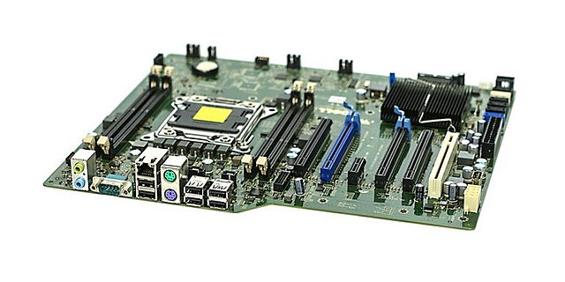

The **motherboard** is the main circuit board in a computer that connects all the essential components, allowing them to communicate with each other. It serves as the backbone of the system, housing the CPU, RAM, storage devices, and expansion cards while also providing connectors for peripherals. The motherboard ensures that all components can work together seamlessly, making it a crucial part of any computer. The motherboard is central to a computer’s functionality. It ensures the proper communication and coordination between the CPU, memory, storage devices, and peripherals. Without the motherboard, none of the system's components would be able to interact, making it an indispensable part of the computer. Additionally, it provides connectivity to various external devices, such as monitors, keyboards, and printers, through its I/O ports.

**Key Components of a Motherboard**

1. **CPU Socket**  
   This is the part of the motherboard where the CPU (Central Processing Unit) is installed. It provides the necessary connections for the CPU to interact with the motherboard. Different CPUs require different types of sockets (e.g., LGA, PGA).
2. **RAM Slots (DIMM Slots)**  
   These are the slots where RAM (Random Access Memory) modules are installed. RAM temporarily stores data and instructions that the CPU needs for processing, improving system performance.
3. **Chipset**  
   The chipset is responsible for managing communication between the CPU, memory, and peripheral devices. It controls data flow and dictates what features the motherboard supports, such as overclocking or RAID functionality. The chipset is often divided into two parts:
   * **Northbridge**: Handles high-speed communication with the CPU, RAM, and GPU.
   * **Southbridge**: Manages slower connections, including storage devices (SATA), USB ports, and PCI slots.
4. **Expansion Slots (PCIe)**  
   These slots allow you to add expansion cards, such as graphics cards (GPU), sound cards, network cards, and other peripherals. The most common expansion slot today is the **PCIe (PCI Express)**, available in different sizes (x1, x4, x8, x16) depending on the card’s needs.
5. **Storage Connectors (SATA, M.2)**  
   These connectors allow for the connection of storage devices like Hard Disk Drives (HDDs), Solid State Drives (SSDs), and optical drives. **SATA** ports are commonly used for HDDs and SSDs, while **M.2** connectors are used for faster SSDs that provide better data transfer rates.
6. **Power Connectors**  
   The motherboard has power connectors that supply the necessary electricity to the CPU, memory, and other components. The primary power connector is the **24-pin ATX** connector, with additional **4/8-pin CPU connectors**.
7. **I/O Ports**  
   These ports are located on the back panel of the motherboard and allow the computer to communicate with external devices. Common I/O ports include **USB**, **HDMI**, **Ethernet**, **audio jacks**, and **VGA/DisplayPort**.
8. **BIOS/UEFI Chip**  
   The BIOS (Basic Input/Output System) or UEFI (Unified Extensible Firmware Interface) is firmware that manages the motherboard’s hardware during boot-up and provides system-level control. It allows users to configure system settings like boot order, CPU settings, and security features.

**3.RAM (Random Acess Memory)**

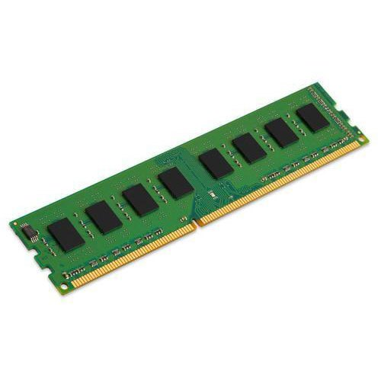

**Random Access Memory (RAM)** is a type of volatile memory used in computers and other devices to store data that is actively being used or processed. Unlike storage devices like hard drives or SSDs, RAM is much faster, allowing quick access to data that the CPU needs to perform tasks. However, RAM is **volatile**, meaning it loses all stored data when the power is turned off.

**Function of RAM**

RAM serves as temporary storage that allows the CPU to quickly access and manipulate data required for running programs and processes. When you open a program, it gets loaded from the hard drive or SSD into the RAM, allowing the CPU to quickly access the data it needs to execute tasks. Without sufficient RAM, a system can experience slow performance, as it has to rely more on slower storage for data retrieval.

**Types of RAM**

There are several types of RAM, each serving different purposes and offering varying performance levels:

1. **DRAM (Dynamic RAM)**  
   DRAM is the most common type of RAM used in personal computers and other devices. It requires regular refreshing to maintain its data, making it slower compared to other types of RAM.
2. **SRAM (Static RAM)**  
   SRAM is faster than DRAM because it does not require refreshing. However, it is more expensive and is typically used for cache memory or small amounts of fast-access storage within the CPU.
3. **DDR (Double Data Rate)**  
   DDR RAM is the most widely used type in modern computers. It transfers data twice per clock cycle, improving performance over older types like SDRAM (Synchronous DRAM). Different versions of DDR RAM include:
   * **DDR2**
   * **DDR3**
   * **DDR4**
   * **DDR5** (latest generation, offering higher speeds and efficiency)
4. **LPDDR (Low Power DDR)**  
   LPDDR is a variant of DDR designed for mobile devices, offering lower power consumption to extend battery life in laptops, tablets, and smartphones.

### ****4.Daughter Cards****

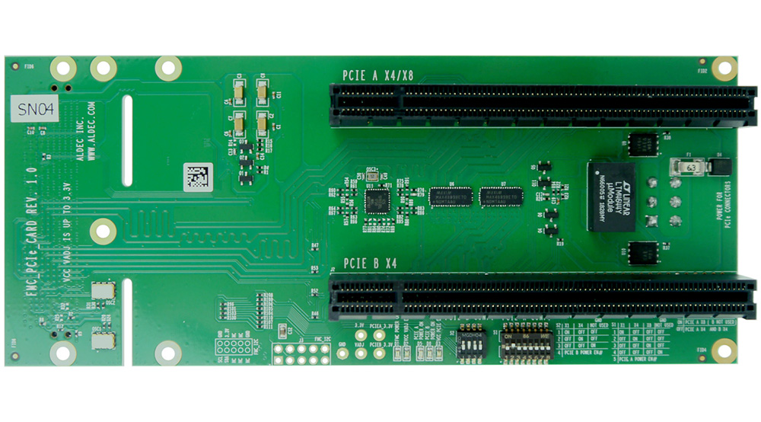

A **daughter card** (or **expansion card**) is a type of circuit board that plugs into the motherboard via a slot and provides additional functionality or features to a computer. The name "daughter card" refers to its relationship with the motherboard, which is considered the "mother" card. Daughter cards allow users to expand the capabilities of a system by adding specific components, such as graphics, audio, networking, or storage controllers.

### ****Bus Slots****

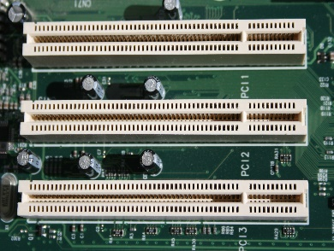

**Bus slots** on a motherboard are physical connectors used to interface different expansion cards (daughter cards) with the central processing unit (CPU) and memory of a computer system. These slots provide the pathways for data to travel between the motherboard and various components, such as graphics cards, network cards, storage controllers, and more. The bus slots allow users to expand and upgrade their system's capabilities by adding specific hardware to meet their needs.

### ****SMPS (Switch Mode Power Supply)****

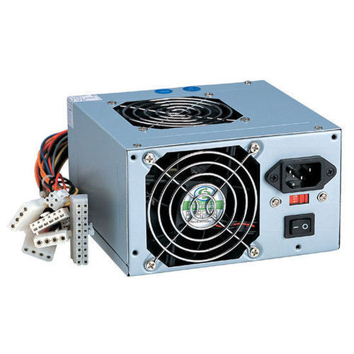

**SMPS (Switch Mode Power Supply)** is an essential component in modern electronic systems, especially in computers. It converts electrical power from an AC (Alternating Current) source, like a wall outlet, into the DC (Direct Current) power required by the internal components of a computer, such as the motherboard, CPU, hard drives, and other peripherals. The SMPS is responsible for regulating the voltage and ensuring a stable supply of power to the system.

**Key Components of SMPS**

1. **Transformer**  
   The transformer is used to step down the AC voltage to a lower voltage suitable for the circuit. In SMPS, transformers also help in isolating different sections of the circuit for safety and performance purposes.
2. **Rectifier**  
   The rectifier converts AC power into DC power. In SMPS, the rectification is done through **diodes** or **silicon-controlled rectifiers (SCRs)** to convert the incoming AC into a pulsating DC voltage.
3. **Switching Transistor**  
   A crucial component of SMPS is the **switching transistor** (often a MOSFET or IGBT). It rapidly switches on and off, controlling the voltage levels and converting the DC to a form that can be efficiently regulated.
4. **Inductor and Capacitors**  
   Inductors and capacitors are used for **filtering** and **stabilizing** the output voltage. They help smooth out any ripples in the DC output caused by the switching process.
5. **Control Circuit**  
   The control circuit monitors and adjusts the switching of the transistor to maintain a stable output voltage. It may include feedback mechanisms to ensure that the voltage remains within the desired range.

**7.Internal Storage Devices**

**Internal storage devices** are the components inside a computer that store data, programs, and system files. Unlike external storage devices, which are used for data transfer and backup, internal storage devices are crucial for the day-to-day operation of the system. They hold the operating system, applications, and user data, providing long-term storage even when the system is powered off. The two most common types of internal storage devices in modern computers are **Hard Disk Drives (HDDs)** and **Solid-State Drives (SSDs)**.

**Types of Internal Storage Devices**

1. **Hard Disk Drive (HDD)**

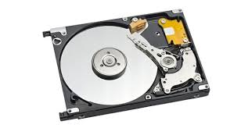

* + **Function**: HDDs use **magnetic storage** to store data on spinning platters. They consist of read/write heads that move across the platters to access data.
  + **Capacity**: HDDs are available in large capacities, commonly ranging from **500GB** to **10TB** or more, making them ideal for users needing large storage space for files, media, or backups.
  + **Speed**: HDDs are slower compared to SSDs because they rely on mechanical movement. Data retrieval and writing depend on the speed of the spinning platters and the position of the read/write heads.
  + **Advantages**:
    - High storage capacity at lower cost.
    - Ideal for mass storage of large files like movies, backups, and databases.
  + **Disadvantages**:
    - Slower performance compared to SSDs.
    - More prone to mechanical failure due to moving parts.

1. **Solid-State Drive (SSD)**

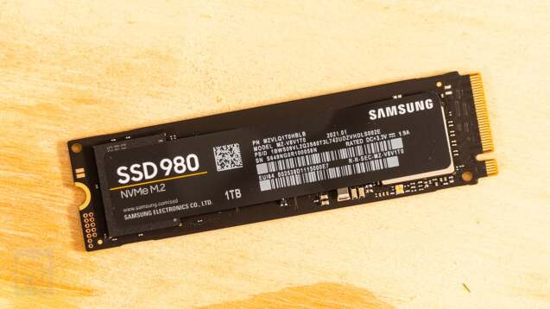

* + **Function**: SSDs store data on **flash memory chips** rather than mechanical parts. Data is stored in **NAND flash memory**, which is faster and more durable than the magnetic platters in HDDs.
  + **Capacity**: SSDs are typically available in sizes ranging from **120GB** to **4TB** for consumer-grade models, with enterprise models offering higher capacities.
  + **Speed**: SSDs offer **dramatically faster** data transfer speeds compared to HDDs. This results in quicker boot times, faster file transfers, and improved system performance.
  + **Advantages**:
    - **Faster speed**: Quick data access, which enhances overall system performance and responsiveness.
    - **Durability**: No moving parts, which makes SSDs more resistant to physical damage and wear.
    - **Energy efficiency**: SSDs consume less power, leading to better battery life in laptops and lower power usage in desktops.
  + **Disadvantages**:
    - **Cost**: SSDs are generally more expensive per gigabyte than HDDs, especially at higher storage capacities.
    - **Limited write cycles**: While SSDs are very reliable, they do have a finite number of write cycles before the memory cells start to degrade.
    - to dedicated SSD solutions.

**8.Interfacing ports**

**Interfacing ports** are connectors on a computer that allow communication and data transfer between the computer and external devices. These ports provide physical access to the system for connecting peripherals like monitors, keyboards, mice, printers, storage devices, and network connections. Different types of ports serve specific functions and use various types of cables or connectors. As technology evolves, new ports are introduced to support faster data transfer rates, enhanced connectivity, and improved compatibility with modern devices.

**Common Types of Interfacing Ports**

1. **USB Ports (Universal Serial Bus)**

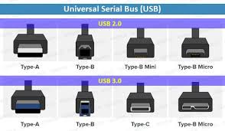

* + **Function**: USB ports are one of the most commonly used interfaces for connecting external devices like keyboards, mice, flash drives, printers, smartphones, and cameras to the computer.
  + **Types**:
    - **USB-A**: The standard rectangular USB port.
    - **USB-B**: Typically used for printers and other peripheral devices.
    - **USB-C**: A newer, reversible connector that supports faster data transfer, power delivery, and video output.
  + **Speed**: USB versions differ in speed: USB 2.0 (up to 480 Mbps), USB 3.0/3.1 (up to 5 Gbps and 10 Gbps), and USB 4.0 (up to 40 Gbps).

1. **HDMI (High-Definition Multimedia Interface)**

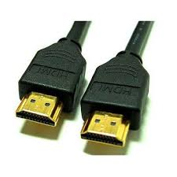

* + **Function**: HDMI ports are primarily used for transmitting high-definition video and audio between a computer and external displays like monitors, TVs, and projectors.
  + **Features**: HDMI can carry both video and audio signals through a single cable, making it a convenient choice for home entertainment and professional settings.
  + **Versions**: HDMI 1.4, 2.0, and 2.1 offer varying levels of performance, with HDMI 2.1 supporting higher resolutions (up to 8K) and higher refresh rates.

1. **VGA (Video Graphics Array)**

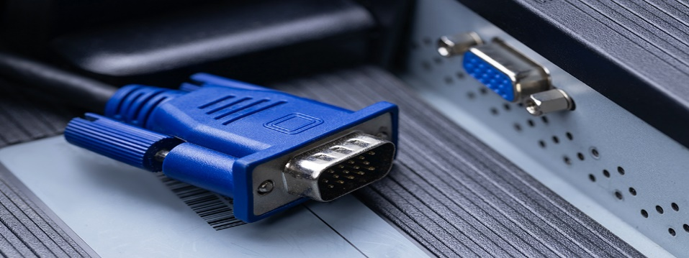

* + **Function**: VGA is an older video interface used for connecting computers to monitors, primarily for analog video transmission.
  + **Features**: While VGA was once a standard for computer displays, it has been largely replaced by digital connections like HDMI and DisplayPort. It typically supports resolutions up to **1080p** but lacks audio transmission.
  + **Physical Identification**: The VGA connector has **15 pins** arranged in three rows and is usually blue.

1. **DisplayPort**

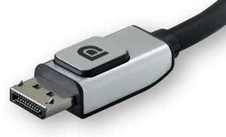

* + **Function**: DisplayPort is a digital display interface that can carry both video and audio signals. It’s commonly used to connect computers to high-performance monitors.
  + **Types**:
    - **DisplayPort** (standard): Supports high-resolution displays and can carry both video and audio.
    - **Mini DisplayPort**: A smaller version, commonly used in some laptops and Apple devices.
  + **Speed**: DisplayPort 1.2 supports up to 21.6 Gbps, while DisplayPort 1.4 supports up to 32.4 Gbps, allowing for higher resolutions and refresh rates.

1. **Ethernet Port (RJ45)**

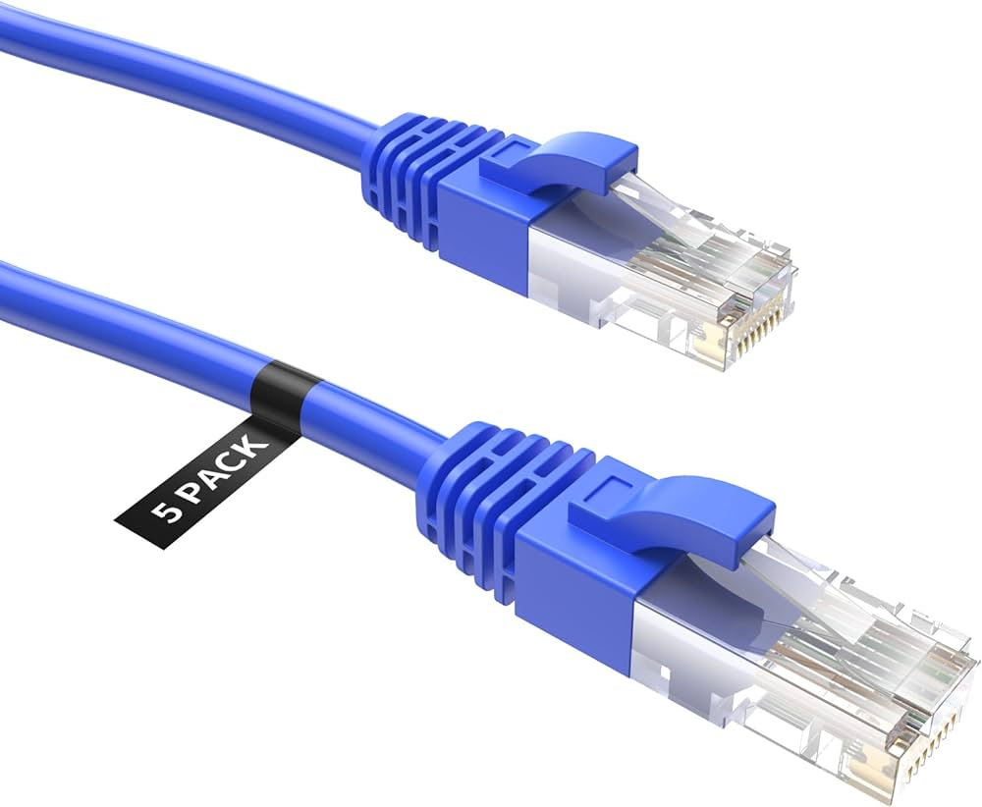

* + **Function**: The Ethernet port is used for wired network connections, such as connecting to a local area network (LAN) or the internet.
  + **Physical Identification**: The port is rectangular, with **8 pins** inside, and uses an **RJ45** connector.
  + **Speed**: Ethernet ports typically support speeds of **100 Mbps**, **1 Gbps**, or **10 Gbps**, depending on the version of the Ethernet standard being used (e.g., **Gigabit Ethernet** or **10G Ethernet**).